Panther ODM

*The following is a simplification of an aircraft ODM – operations data manual. It is for a fictional aircraft using fictional data.*

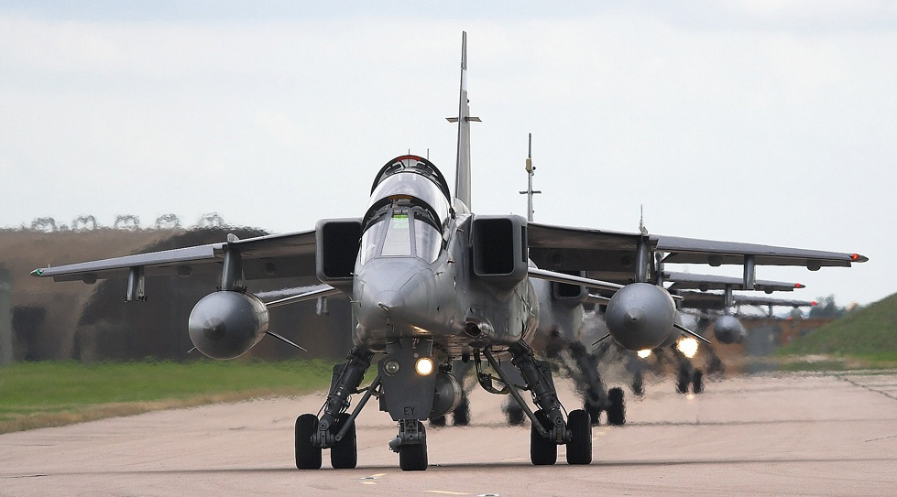

# Overview

The ODM or operations data manual is a core part of mission planning for aircraft. It allows uses to make plans around their expected fuel usage.

The fuel used on an aircraft during a mission varies on a number of factors,

* The weight of the aircraft (also called all-up-weight AUW). The heavier the aircraft, the more fuel it uses
* How high the aircraft is flying. The higher the aircraft flies, the more fuel efficient it is. Unfortunately in enemy territory, it’s more prudent to do low level flying, which helps to mask the aircraft.
* Speed of the aircraft. The faster an aircraft flies, the faster the more fuel it uses.

The ODM class in Java replaces a manual process which was traditionally done with paper and pencil. This process will be described in the rest of this document, along with copies of the data table, which can function to allow you to flesh out test ideas.

The aim of this is to plan out a mission, and be sure that an aircraft has enough fuel to return to base with. Typically it’s expected to land with a minimum of 300kg of fuel “just in case”.

# Introduction to the Panther

The Panther is a fictional aircraft. At base weight with a pilot, it weighs 6,000kg.

The aircraft has a range of hard points under the fuselage, which allow the air force to mount a different range of equipment and munitions according to the mission they want to fly.

# Units used throughout

To help you, here is an explanation of some of the units used throughout this technical document.

|  |  |
| --- | --- |
| **Unit** | **Description** |
| nm | Nautical mile. This is a slightly different to a standard mile. |
| kts | Knots. This is the number of nautical miles travelled per hour. |
| ft | Feet. All altitudes are measured in feet. |
| kg | Kilogram. All weights are measured in kilograms. |

# Equipment

The Panther has the capacity to carry several pieces of equipment including

* A2A missile – these are anti-aircraft missiles which weight 150kg each. Typically carry 4 of them up to a max of 8. Use of these missiles is ad-hoc when required to defend the aircraft. Hence when fitted with them, there’s an expectation from evaluating fuel usage that they’ll land with them.
* Recon pod – the recon pod is for flying over potential targets to take pictures of them for intelligence and analysis purposes. The recon pod weighs 800kg, and hard point slots that bombs typically use. Hence, when this is fitted bombs of any kind cannot be carried (dumb or IntelliBomb). To take recon pictures over a target, the aircraft needs to be under 10,000 ft. Panther can carry the recon pod in combination with fuel tanks and A2A missiles.
* Dumb bomb – it’s a basic, unguided bomb. It gets dropped, and falls to the Earth going “boom”. Each bomb weighs 600kg, and the Panther has hard points to carry up to 6 of them, although 4 is standard. These bombs have to be dropped at low level, below 5,000ft to be effective.
* IntelliBomb – this is guided bomb, which glides to its target which can be up to 30NM away. The Panther can only carry one of these at 2000kg. It cannot be mixed with a Dumb bomb payload. The Panther can carry an IntelliBomb in combination with fuel tanks and A2A missiles.
* External fuel tanks. Normally the Panther can only carry up to 3000kg of fuel. The Panther can carry one pair of external fuel tanks, which together weight 200kg (which is the weight of the empty tanks). This extends the fuel capacity of the aircraft to 6000kg. You cannot add additional fuel tanks.

When selecting the layout of equipment, the pilot works out the EQUIPMENT WEIGHT by adding together all the pieces of equipment which have been added

## Examples

***“Recon Panther”***

A Panther equipped for recon over a hostile area. It’s expecting a lot of trouble, so will be equipped with the max load of A2A missiles (8) plus its recon pod. But the target is close enough that no external fuel pods are needed.

EQUIPMENT WEIGHT = ( 8 x A2A missiles ) + ( 1 x Recon Pod )

= ( 8 x 150 ) + 800

= 2000kg

***“Dumb Loaded Panther”***

A Panther is going into a hot zone with a dumb bomb layout. Will expect to need four A2A missiles, but it’s expected to just need three dumb bombs, although external fuel pods will be needed.

EQUIPMENT WEIGHT = ( 4 x A2A missiles ) + ( 3 x Dumb Bomb ) + (Fuel Tanks)

= ( 4 x 150 ) + ( 3 x 600 ) + ( 200 )

= 2600kg

Note that the equipment weight will vary for a mission. If the above aircraft is ordered over a target to release two bombs, the EQUIPMENT WEIGHT will alter as below …

NEW EQUIPMENT WEIGHT = ( 4 x A2A missiles ) + ( 1 x Dumb Bomb ) + (Fuel Tanks)

= ( 4 x 150 ) + ( 1 x 600 ) + ( 200 )

= 1400kg

# Keeping track of remaining fuel

For each leg or maneuverer the aircraft takes, the fuel usage is calculated, and removed from the fuel remaining. This will mean the aircraft will change weight, which will change its usage on later legs.

The easiest use of fuel change is for climbing and diving, and we’ll look at this first …

## Climbing and diving

Fuel is also used when an aircraft climbs in altitude at a rate of 1kg of fuel for every 100ft climbed. *[To keep things easily, this is a simplification, and we’re not varying this by weight]*

When an aircraft dives, its altitude will drop, but there will be no additional fuel lost.

### Example

A reconnaissance Panther takes off and climbs to 30,000ft. It will use 300kg of fuel to do this (= 30,000 ft * 1 kg / 100 ft).

The Panther then drops to 10,000ft to use its reconnaissance pod. This uses no fuel.

After it’s flown over its target, it will climb again to 30,000ft, which will use another 200kg of fuel. This is because it’s climbing from 10,000ft to 30,000ft (= 20,000ft climb), at 1 kg / 100 ft.

## Calculating all-up weight

The all-up weight AUW is a simple calculation – all you need to do is to add together the aircraft weight (6000kg) together with the EQUIPMENT_WEIGHT and REMAINING_FUEL.

AUW = AIRCRAFT_WEIGHT + EQUIPMENT_WEIGHT + REMAINING_FUEL

## Calculating fuel used for a leg

On a mission an aircraft will travel to multiple points before returning to land. Each significant point it flies over is called a waypoint.

An example is shown below – a Panther flies on a round trip from Wellington to Napier to Auckland to New Plymouth to Wellington. The route is broken down into four parts of “legs” of the journey …

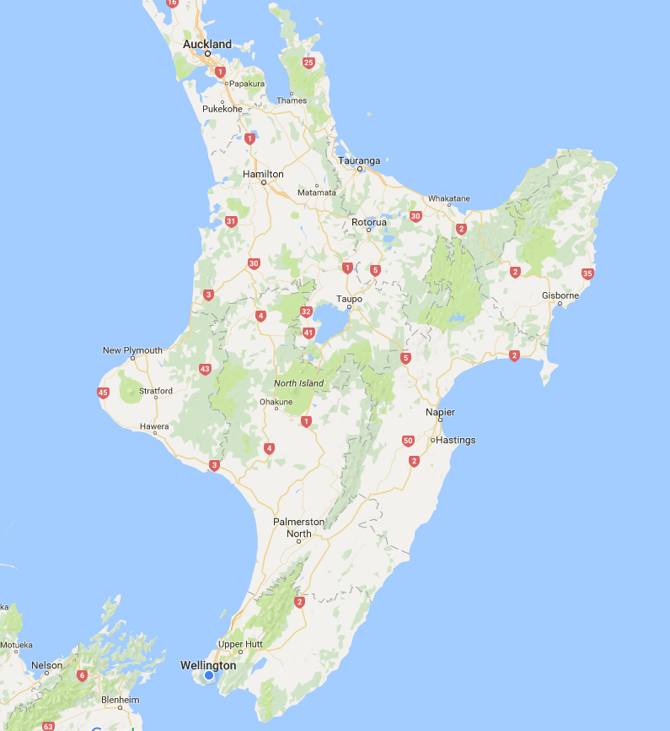

For each leg, once an aircraft’s altitude has been set, and it’s AUW calculated accounting for any fuel used and equipment such as bombs which has been released, you need to determine the amount of fuel used.

To do this, you need to additionally know the speed and length the leg of your journey that the aircraft will fly at.

To find the fuel used you need to find the rate of fuel consumption from the ODM fuel tables – these are multiple tables for which data has been researched for over years. You first find the table that corresponds to the speed you’re going, then look up the value for the altitude you’re flying at, and the current AUW of the aircraft.

The first thing you’ll notice is that not every value is present – there are discrete data values available.

The system is quite critical – and errs to the side of caution, so when finding the fuel consumption, you need to,

* Round the speed up to the nearest available speed for which there is a table
* Round weight up to the nearest available value in a table
* Round altitude down to the nearest available value in a table

So for instance, you’re travelling at 440kts, your current AUW is 12100 and your altitude is 28,000ft,

* Round speed up to 500kts
* Round weight up to 13000 kg
* Round altitude down to 16,000ft

This will give you a value of FUEL_USAGE – the level of kgs of fuel that you use each minute, looking at the table you’ll see it should be 21.3kg/minute.

To calculate the fuel usage for a leg of a journey of length NM_LENGTH, where this is in nautical miles, you take

FUEL_USED = FUEL_USAGE x NM_LENGTH x 60 / AC_SPEED

So in the example above where we’re travelling at 405kts, if we’re travelling for 400nm that should be

FUEL_USED = 21.3 * 400 * 60 / 440 = 1161.8181… kg

You then use this value to amend the fuel remaining with,

REMAINING_FUEL = OLD_ REMAINING_FUEL – FUEL_USED

= 12100 – 1161.82 = 10939 kg

You then recalculate the new AUW for future legs. So for instance, if we continue at this speed and altitude for another 200 nm afterward, the new all up weight means we should be looking in our table under 11,000 kg all up weight, or 19.9 kg / minute.

So now,

FUEL_USED = FUEL_USAGE x NM_LENGTH x 60 / AC_SPEED

= 19.9 * 200 * 60 / 440 = 542.72727… kg

# Adding fuel

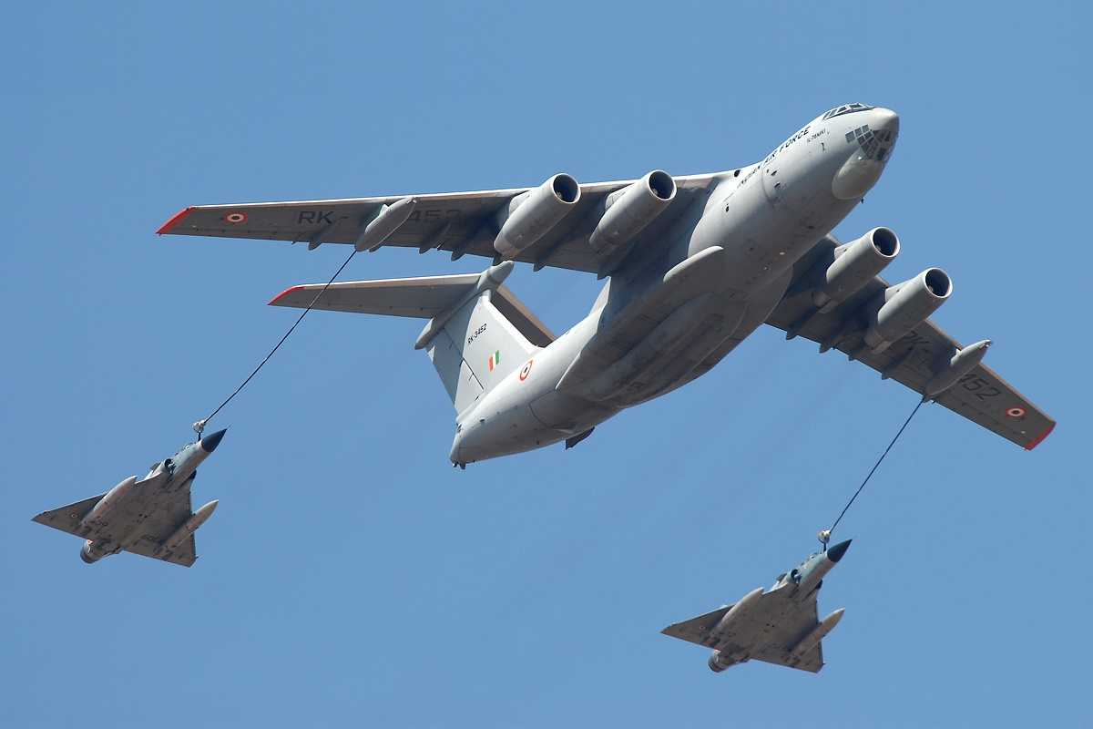

Obviously, you can add fuel to your aircraft whilst it’s on the ground before take-off, but it cannot exceed the maximum allowable fuel.

Once the aircraft has taken off, it’s possible to do an in-air refuelling, although the aircraft must be above 10,000ft in altitude and again cannot take of more fuel than its allowed maximum.

# Fuel usage charts

## Fuel usage 400kts speed

Fuel is in kg / min

|  |  |  |  |  |  |  |  |  |  |  |
| --- | --- | --- | --- | --- | --- | --- | --- | --- | --- | --- |
|  | **7000**  **kg** | **8000**  **kg** | **9000**  **kg** | **10000**  **kg** | **11000**  **kg** | **12000**  **kg** | **13000**  **kg** | **14000**  **kg** | **15000**  **kg** | **16000**  **kg** |
| **0ft** | 26.2 | 27.1 | 28.1 | 29.0 | 30.1 | 31.1 | 32.2 | 33.4 | 34.5 | 35.7 |
| **500ft** | 23.8 | 24.7 | 25.5 | 26.4 | 27.4 | 28.3 | 29.3 | 30.3 | 31.4 | 32.5 |
| **2,000ft** | 21.8 | 22.6 | 23.4 | 24.2 | 25.1 | 25.9 | 26.8 | 27.8 | 28.8 | 29.8 |
| **8,000ft** | 16.5 | 17.1 | 17.7 | 18.3 | 18.9 | 19.6 | 20.3 | 21.0 | 21.8 | 22.5 |
| **16,000ft** | 12.3 | 12.7 | 13.2 | 13.6 | 14.1 | 14.6 | 15.1 | 15.7 | 16.2 | 16.8 |
| **32,000ft** | 6.8 | 7.0 | 7.3 | 7.6 | 7.8 | 8.1 | 8.4 | 8.7 | 9.0 | 9.3 |

## Fuel usage 500kts speed

Fuel is in kg / min

|  |  |  |  |  |  |  |  |  |  |  |
| --- | --- | --- | --- | --- | --- | --- | --- | --- | --- | --- |
|  | **7000**  **Kg** | **8000**  **kg** | **9000**  **kg** | **10000**  **kg** | **11000**  **kg** | **12000**  **kg** | **13000**  **kg** | **14000**  **kg** | **15000**  **kg** | **16000**  **kg** |
| **0ft** | 36.8 | 38.1 | 39.5 | 40.9 | 42.3 | 43.8 | 45.3 | 46.9 | 48.6 | 50.3 |
| **500ft** | 33.5 | 34.7 | 35.9 | 37.2 | 38.5 | 39.9 | 41.3 | 42.7 | 44.2 | 45.8 |
| **2,000ft** | 30.7 | 31.8 | 32.9 | 34.1 | 35.3 | 36.5 | 37.8 | 39.1 | 40.5 | 41.9 |
| **8,000ft** | 23.2 | 24.0 | 24.9 | 25.7 | 26.7 | 27.6 | 28.6 | 29.6 | 30.6 | 31.7 |
| **16,000ft** | 17.3 | 17.9 | 18.6 | 19.2 | 19.9 | 20.6 | 21.3 | 22.1 | 22.8 | 23.6 |
| **32,000ft** | 9.6 | 9.9 | 10.3 | 10.6 | 11.0 | 11.4 | 11.8 | 12.2 | 12.6 | 13.1 |

## Fuel usage 600kts speed

Fuel is in kg / min

|  |  |  |  |  |  |  |  |  |  |  |
| --- | --- | --- | --- | --- | --- | --- | --- | --- | --- | --- |
|  | **7000**  **kg** | **8000**  **kg** | **9000**  **kg** | **10000**  **kg** | **11000**  **kg** | **12000**  **kg** | **13000**  **kg** | **14000**  **kg** | **15000**  **kg** | **16000**  **kg** |
| **0ft** | 55.3 | 57.2 | 59.2 | 61.3 | 63.5 | 65.7 | 68.0 | 70.4 | 72.9 | 75.5 |
| **500ft** | 50.3 | 52.1 | 53.9 | 55.8 | 57.8 | 59.8 | 61.9 | 64.1 | 66.3 | 68.7 |
| **2,000ft** | 46.1 | 47.7 | 49.4 | 51.1 | 52.9 | 54.8 | 56.7 | 58.7 | 60.7 | 62.9 |
| **8,000ft** | 34.8 | 36.0 | 37.3 | 38.6 | 40.0 | 41.4 | 42.8 | 44.4 | 45.9 | 47.5 |
| **16,000ft** | 26.0 | 26.9 | 27.8 | 28.8 | 29.8 | 30.9 | 32.0 | 33.1 | 34.3 | 35.5 |
| **32,000ft** | 14.4 | 14.9 | 15.4 | 15.9 | 16.5 | 17.1 | 17.7 | 18.3 | 19.0 | 19.6 |

## Fuel usage data provision

The fuel usage data is collected by PantherOps, and undergoes occasional revision as they run test flights on the aircraft.

This information is provided by a file called fuel_data.txt

It’s provided in the format

| Height | Speed | Weight | Fuel Usage |

Because this file is so mission critical, there are strict rules handling of this file. The system must fail if,

* Any line contains and more or less than 4 sets of data separated by |
* Any set of data does not convert to a number
* There are less than 180 data entries

This is because it’s seen as better to make a flight crew calculate fuel usage manually than accept a value from the system where data was missing.

# Detailed example

A Panther aircraft is going to take part in a live exercise at the army base in Waioru, and will be dropping unarmed “dumb bombs” on a firing range.

## Equipment

The aircraft will be armed with 4 dumb bombs and 8 air-to-air missiles.

It will be carrying fuel tanks and a total of 5000kg of fuel.

This should give it an all up weight of 14,800kg.

## Cruise to Palmerston North

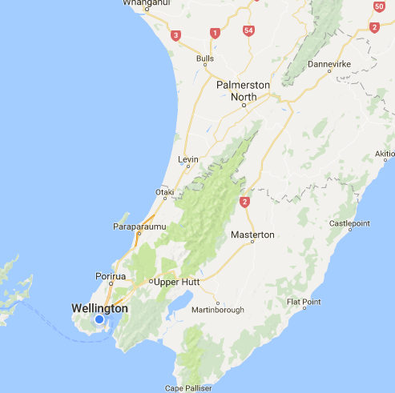

The aircraft will take off from Wellington, and climb to 20,000 ft using 200kg of fuel. From here it will fly at 400kts until it reaches Palmerston North. This is a distance of 75 nm.

The aircraft should have at this point an all up weight of 14,600kg. Using the 400kts table, weight of 15,000kg and altitude of 16,000ft – this should mean its consuming 16.2kg/min of fuel.

At 400kts, it should take 11.25 mins to travel this (= 60mins x 75nm / 400kts).

Hence it should use 182.25kg of fuel (=11.25mins x 16.2kg/min).

## Attack run to Waioru

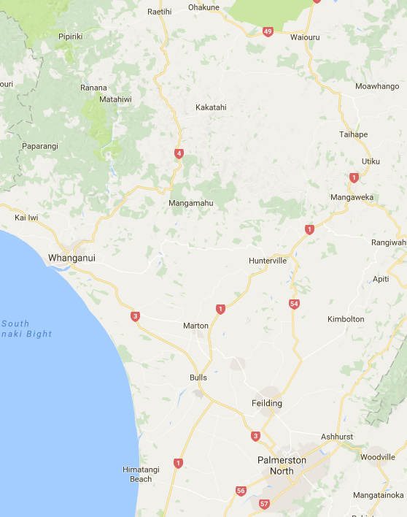

From Palmerston North to Waioru it will fly at only 200ft to keep a low radar profile. It will accelerate to an attack speed of 600kts. This is a distance of 86nm.

The aircraft should have at this point an all up weight of 14,417.75kg. Using the 600kts table, weight of 15,000kg and altitude of 0ft – this should mean its consuming 72.9kg/min of fuel.

At 600kts, it should take 8.6 mins to travel this (= 60mins x 86nm / 600kts).

Hence it should use 626.94kg of fuel (=8.6mins x 72.9kg/min).

## Escape to Whanganui



At Waioru it will drop 4 of its dumb bombs, and climb to 1000ft. The climb will use 8kg of fuel.

At this point, combined with the loss of its 4 bombs, the aircraft weight will be 11,109.89kg.

It will then cruise to Whanganui at 500kts. This is a distance of 57nm.

Using the 500kts table, weight of 12,000kg and altitude of 500ft – this should mean its consuming 39.9kg/min of fuel.

At 500kts, it should take 6.84 mins to travel this (= 60mins x 57nm / 500kts).

Hence it should use 272.92kg of fuel (=6.48 mins x 39.9kg/min).

## Refuel at Whanganui

At Whanganui, a tanker will be waiting to perform an in-air refuel.

The aircraft will climb to 18,000 feet, and take on 2000kg of fuel.

At this point the aircraft weight will be 12799.89kg.

## Cruise to Sydney

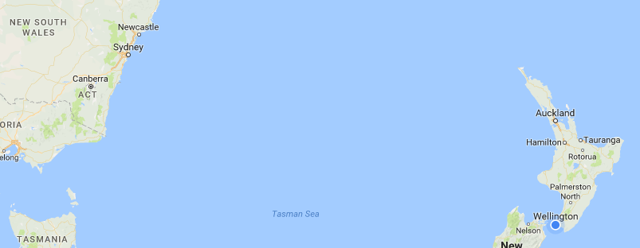

The aircraft is due to take part in a trade show at Sydney. From Whanganui it will fly non-stop at 500kts to Sydney at 32,000ft. This is a distance of 1188nm.

Using the 500kts table, weight of 13,000kg and altitude of 32000ft – this should mean its consuming 11.8kg/min of fuel.

At 500kts, it should take 142.56mins to travel this (= 60mins x 1188nm / 500kts).

Hence it should use 1682.21kg of fuel (=142.56 mins x 11.8kg/min).

# Source

If you’re interested in knowing more, a real life copy of the Jaguar ODM can be found here …

<http://www.avialogs.com/en/aircraft/europe-and-consortiums/sepecat/jaguar/ap-101b-3100-16-jaguar-aircraft-operating-data-manual.html>